Resource File Internal Formats
The NodeBuilder Device Resource File Editor uses a formatting library that is also part of the iLON system image. The .typ, .fpt, and .fmt files that it generates have an internal file format version that has changed over time and are handled by the formatting library. The following screen capture shows properties reported by the resource file editor version 4.02.

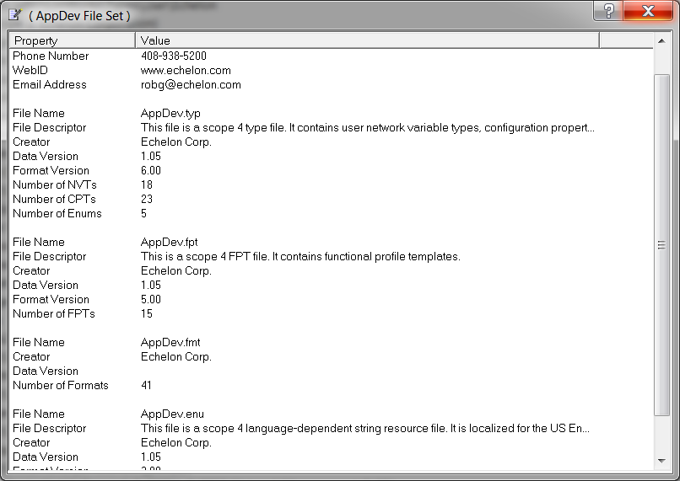
The formatting library supports the reading of down level .typ file formats, but will only write the files using the most current version (.typ 6.0). If you open a resource file and make a change the internal file formats will be promoted if you are using version 4.01 or higher.
If an iLON below version 4.06.xxx accesses type formats in a file set using the .typ files using internal version 6 the results are fatal.
To support the universe of iLON versions, after making changes to the resource files you need to use the Resource File Converter to down grade the .typ format as shown in this screen shot:
